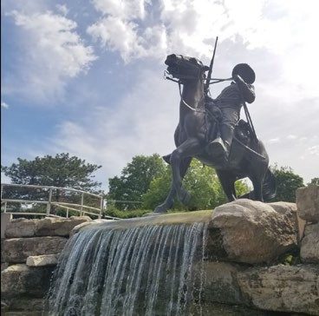
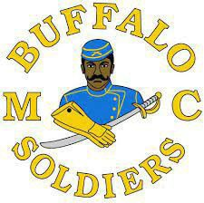
Buffalo Soldiers Motorcycle Club Fort Leavenworth, Kansas Chapter(BSMCFLKS)

2024 Scholarship Program
HTTPS://WWW.BSMCFLKS.COM
Dear 2024 Scholarship Candidate,

- Please read all the scholarship application paperwork closely and follow the instructions carefully.

- Instructions for candidates: Attach or scan the completed application only (typically page 3 through page 5); do not include the general information pages and instructions pages. Complete all forms in its entirety and attach additional pages, if required. Completed applications and required documents must be attached as MS Word documents or scanned in a PDF format, in ONE (1) PDF file (JPEG and GIF image formats will be rejected). The following are required to complete your application:
  - Applicant must be an eligible Graduating High School Senior/GED recipient during the
Fall 2023 / Spring 2024 / Summer 2023 school year with a minimum GPA of 2.0 who will be attending post-secondary or vocational/trade school in the 2024-2025 school year
  - Unofficial High School Transcript, Home School Transcript or GED Certificate
  - A 500-word essay on the topics described below in Essay Topics
  - Letter of recommendation from a teacher/guidance counselor/school administrator on official letterhead
  - Letter of recommendation on letterhead from a community service organization
  - A letter of acceptance to an institution of higher learning
  - Signed Release Form (enclosed)
  - Parent's signature if the student is under 18 years of age
  - Prepare a letter of introduction: who you are, your accomplishments to date, family background, financial need, and the degree/certificate which you are pursuing.
  - Provide a summary on how you plan to use the scholarship and incorporate how this scholarship would benefit you in giving back to your community, if selected.
  - Recent professional headshot photo (in good taste)
  - Provide Student's name, the complete name and address of the school and/or financial aid officewhere the student will be attending school and student ID number.

Incomplete applications will automatically be eliminated.

- Essay Topics: Write a 500-word essay (typewritten) on one of the following topics:
**Do not write about the Buffalo Soldiers or Buffalo Troopers Motorcycle Club**
- What impact did the Buffalo Soldiers make in war and/or peacetime? Why is it necessary to passthis legacy on to future generations?

- Provide specific examples of how the Buffalo Soldiers facilitated the development of roadways, national parks, and mail service.

- The Congressional Medal of Honor is presented to the recipient by the President of the United States in the name of Congress. Please provide a brief narrative regarding a Buffalo Soldier that received this honor and what can be learned from his life, efforts, and commitment to duty.

- When you complete all the requirements, send the final PDF format version electronically via email to the following Kansas local chapter address no later than
1 April 2024 for review and assessment:

Kansas State Local Chapter BSMCFLKS Chapter
ATTN: Scholarship Chairman PO Box 3022
Fort Leavenworth, KS 66027 Email: BSMC.FLKS@gmail.com Website: www.bsmcflks.com

- In your scholarship candidate email: Subject line is your full name, City and State. Unofficial transcripts can be scanned in the PDF format because JPEG and GIF image formats will be rejected. Completed applications and required documents must be attached as MS Word documents or scanned in PDF format, in ONE (1) PDF file and emailed to the local Buffalo Soldiers Motorcycle Club chapter on or before the stated deadline. Applications must be vetted and forwarded from the nearest local Buffalo Soldiers Motorcycle Club chapter to the Frontier Chairperson.

Submit Application:

- The BSMCFLKS Chapter will review all applications and determine which selected applications are forwarded to the Central Frontier for consideration to compete at the Frontier or NABSTMC National level. Each local chapter, within their respective frontier, is allowed to send no more than three (3) scholarship application packets (4-year, 2-year or vocational) to their respective frontier scholarship chairperson on or before the stated 1 April 2024 Frontier deadline. Scholarship applications may be downloaded from https://www.bsmcflks.com/ under the scholarship tab you will find the 2024 Scholarship application.

Incomplete packets will be eliminated.

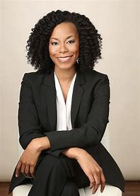
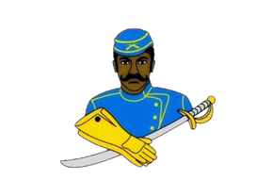
Buffalo Soldier Motorcycle Club of Fort Leavenworth, Kansas
(BSMCFLKS) Scholarship Program
2024 Application
Application Deadline: 1 April 2024

Name of local Buffalo Soldier Chapter:
Contact Information:
First Name: |  | Last Name:
Address:
City: |  | State:
Zip Code: |  | Email:
Home Phone: |  | Cell Phone:
Date of Birth: |  | Gender:

Academic Information:
High School Name: |  | City / State
Graduation Date:

College Information (If you have not finalized your college choice, provide your first-choice school.):
College Name: |  |  |  | City / State:
Institution Type: Certificate Four-Year |  | Two-Year | Vocational or Technical:
Degree Sought: Associates |  | Bachelors | Certificate
Major:
Anticipated Graduation Date:
Photo Goes Here

Applicant Service, Extracurricular Activities, and Work Experience:
Use this space to provide the applicant’s volunteer service, extracurricular activities, and work experience during the applicant’s academic career. Do not attach a resume in lieu of completing this form. It will not be reviewed.

Description
Total Hours or Average Hours per week: |  | Are you still participating? (yes/no) | No
Start Date: |  | End Date:
Highest Position Held:

Description
Total Hours or Average Hours per week: |  | Are you still participating? (yes/no) | Yes
Start Date: |  | End Date:
Highest Position Held:

Description
Total Hours or Average Hours per week: |  | Are you still participating? (yes/no) | Yes
Start Date: |  | End Date:
Highest Position Held:

Terms & Conditions:

I, , certify, to the best of my knowledge, that the information on this application is complete and accurate. Falsification of any information will cause my disqualification from the scholarship competition.
- It is my responsibility to make sure the application process is complete by the required deadline. If not, the application may be disqualified from the scholarship competition and may not be considered for an award.
- This application, upon receipt, becomes the property of the program sponsor.

I agree that, if selected as an award winner for the Buffalo Soldiers Motorcycle Club of Fort Leavenworth Kansas Chapter Scholarship Program, the program sponsor or its agents may use my name and likeness and any other information or materials provided in connection with this program for purposes of news, publicity and advertising in all media, including but not limited to print and electronic media, press releases, internet websites and video media.

To comply with the provisions of the Family Educational and Privacy Act of 1974, I hereby grant permission for school officials to release secondary school records and other requested information, if necessary.
If you are under 18, your parent or guardian must also agree to these Terms and Conditions.

Applicant Signature: Date:

Parent Signature: (if applicable)

** Local Chapter/Frontier must acknowledge receipt before sending to National Scholarship Committee.

Chapter: B S M C Fort Leavenworth, Kansas Signature: Corey "Ghost" Jenkins

